Rotary International District 5500 Indoor Ride to End Polio
FREQUENTLY ASKED QUESTIONS

- What is the Indoor Ride to End Polio?
The Indoor Ride is a ready-made polio fundraising event open to every Rotary Club, Rotary District and Rotarian in the world. The Indoor Ride is a complement to the Ride to End Polio, a bicycling fundraiser held each November in Tucson, Arizona, USA, in conjunction with El Tour de Tucson, one of the largest perimeter bicycling events in the US. El Tour, organized by Perimeter Bicycling Association of America, annually attracts more than 8,000 cyclists. The Indoor Ride allows riders across the country and around the world to participate without coming to Tucson by riding stationary bikes at home or in a gym, collecting donations for each minute of the ride.

- How can my club or district participate?
Form a team in your club or district. There is no maximum or minimum number of cyclists. Team members collect pledges and donations for each minute they commit to ride, and then hop on stationary bikes for the self-selected length of time at the local gym or at home any time during the period Nov 11-18.

- How can my club or district register? Go to the “registration” tab http://ridetoendpolio.org.

- How does this event raise funds to support Rotary’s top priority, the eradication of polio?
Each rider solicits donations to PolioPlus in support of the ride (for example, some riders may ask $1 per minute).

- How are contributions made?
D5500 recommends that all contributions be made on line through special Crowdfunding pages at www.rotary.org. Checks and cash (collected by riders or teams) are acceptable.

- How are the contributions tracked?
Contributions made on an on-line fundaraising page are automatically tracked. Each rider is requested to track contributions made by cash or check and to ensure that such contributions go to the Rotary Foundation PolioPlus fund. Indoor team leaders are encouraged to track team totals (on-line and off-line) and to report totals to D5500.

- How long must a participant ride?
Indoor riders can ride choose any number of minutes consistent with their level of fitness.

- Must the indoor ride be completed at one time?
Yes. Each rider must complete the indoor ride in one “sitting” any time during the period Nov 11-18. It is not necessary for all riders on a club or district team to ride together.

- Where is the Indoor ride conducted?
Indoor riders can ride a stationary bike anywhere (for example, at home or a local gym).

- Who can ride for Rotary?
Anyone can be a member of the End Polio Now Team. Your club or district team can include Rotarians, family members (parents, children, grandchildren, aunts, uncles, cousins, etc) and friends, Rotaractors and Interactors.

- What support is provided by D5500?
D5500 will provide a fundraising packet to each team leader (and to each individiual indoor rider not on a team). The packet provides strategies for success, procedures for setting up and using a Crowdfunding page on the RI website, sample fundraising letter, and much more. The District also publishes a periodic newsletter with information about the ride and our fundraising progress.

- Is there a registration fee?
There is no team registration fee. However, D5500 encourages each indoor rider to register with Perimeter Bicycling and pay the registration fee established for Indoor El Tour de Tucson at the time of registration. Go to the “registration” tab at http://ridetoendpolio.org. These fees go to Perimeter Bicycling and do NOT support D5500 or PolioPlus. Perimeter Bicycling has established the following fee structure for the Indoor El tour de Tucson:
- $10. Perimeter Bicycling will provide each registered rider with an electronic certificate and electronic bib number. Upon completion of the ride, the rider will receive from Perimeter Bicycling an electronic certificate of completion.
- $20. Available only for riders in the United States. Riders on teams in the United States who pay the full $20 registration fee and who complete the indoor ride will receive an Indoor El tour de Tucson medal in addition to the above listed items.

- What recognition is provided?
The top individual fundraiser worldwide (indoor or outdoor) is identified on the Harris Trophy on display at Rotary International Headquarters in Evanston, Il, USA. The top fundraising club and district for Indoor Ride to End Polio will be identified on the Harris Trophy as well. Determination of the top fundraising club and district teams is based on reporting by the team captain to D5500, not on the on-line totals. In other words, to be eligible for the trophy, team captains must report fundraising totals to D5500. In addition, top fundraisers will be recognized on the Ride to End Polio website. Registered indoor riders receive recognition from Perimeter Bicycling as identified above.

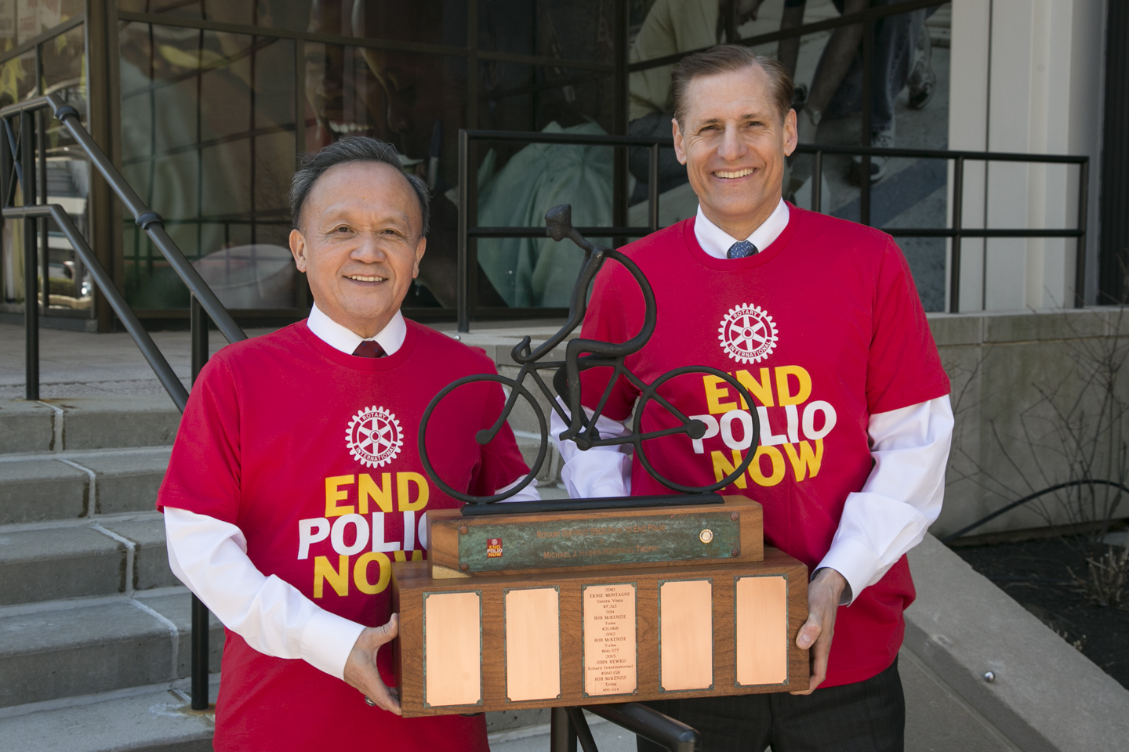
- What is the Harris Trophy?
On display at Rotary International Headquarters in Evanston, the trophy recognizes Michael J. Harris, who initiated the Ride to End Polio. Michael passed away a few months after completing the 2010 ride, but his legacy lives on. Each year the names of the most successful fundraisers are inscribed on the trophy.

- Is special cycling clothing available for riders?
Yes. Riders can order End Polio Now jerseys and shorts at www.ridetoendpolio.org. Click on the “clothing” tab.

- What fundraising successes have been achieved?
In 2016 the Ride to End Polio (indoor and outdoor) raised US$11.3 million (with the Gates Foundation 2-1 match). Since its inception, the event has raised more than US$35 million, enough to purchase more than 50 million doses of polio vaccine.

- What is the fundraising goal for 2017?
$10 million including the match from the Bill and Melinda Gates Foundation.

- Will funds raised qualify for the Gates Foundation match?
Yes. The Gates Foundation provides a 2-1 match for all funds donated by Rotarians to PolioPlus (up to $35 million).

- What perks are provided by El Tour de Tucson?
Perimeter Bicycling provides to each registered rider the materials identified above in accordance with the established fee structure.

